C:\Users\kcrill\AppData\Local\Microsoft\Windows\Temporary Internet Files\Content.IE5\0U8C0ZJ9\MC900155008[1].wmfFood for All Name:___________________

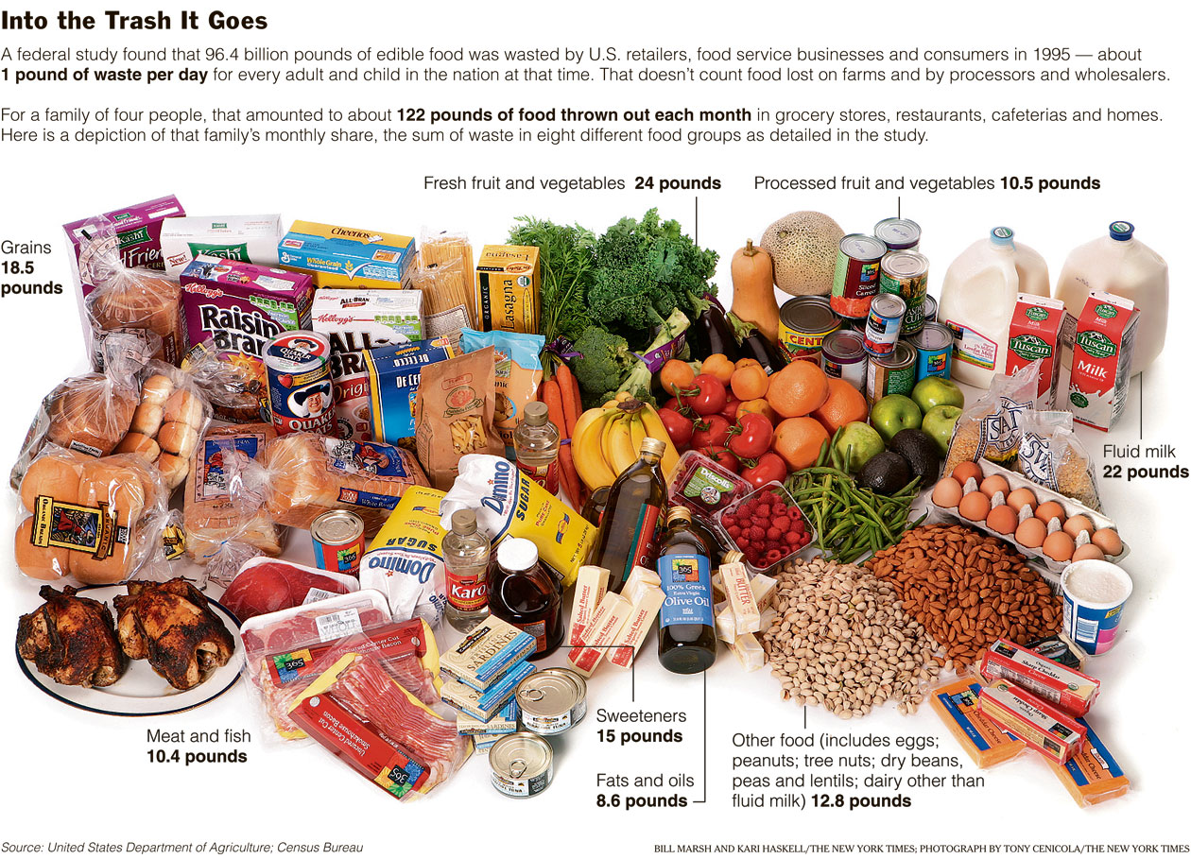

Create a ratio table to show what portion of the wasted food comes from each food category:

Grains

Meat and fish

Fresh fruit and vegetables

Processed fruit and vegetables

Fluid milk

Sweetners

Fats and oils

Other foods



**May 18, 2008 The World**

**One Country’s Table Scraps, Another Country’s Meal By** [**ANDREW MARTIN**](http://topics.nytimes.com/top/reference/timestopics/people/m/andrew_martin/index.html?inline=nyt-per)

Grocery bills are rising through the roof. Food banks are running short of donations. Food shortages are causing sporadic riots in poor countries through the world.

You’d never know it if you saw what was ending up in your landfill. As it turns out, Americans waste an astounding amount of food — an estimated 27 percent of the food available for consumption, according to a government study — and it happens at the supermarket, in restaurants and cafeterias and in your very own kitchen. It works out to about a pound of food every day for every American.

Grocery stores discard products because of spoilage or minor cosmetic blemishes. Restaurants throw away what they don’t use. Consumers toss out everything from bananas that have turned brown to last week’s Chinese leftovers. In 1997, in one of the few studies of food waste, the Department of Agriculture estimated that two years before, 96.4 billion pounds of the 356 billion pounds of edible food in the United States was never eaten. Fresh produce, milk, grain products and sweeteners made up two-thirds of the waste.

The study didn’t account for the explosion of ready-to-eat foods now available at supermarkets, from rotisserie chickens to sandwiches and soups. What do you think happens to that potato salad and meatloaf at the end of the day?

A more recent study by the [Environmental Protection Agency](http://topics.nytimes.com/top/reference/timestopics/organizations/e/environmental_protection_agency/index.html?inline=nyt-org) estimated that Americans generate roughly 30 million tons of food waste each year, which is about 12 percent of the total waste stream. All but about 2 percent of that food waste ends up in landfills; by comparison, 62 percent of yard waste is composted.

The numbers seem all the more staggering now, given the cost of groceries and the emerging food crisis abroad.

After President Bush said recently that India’s burgeoning middle class was helping to push up [food prices](http://topics.nytimes.com/top/reference/timestopics/subjects/f/food_prices/index.html?inline=nyt-classifier) by demanding better food, officials in India complained that not only do Americans eat too much — if they slimmed down to the weight of middle-class Indians, said one, “many people in sub-Saharan Africa would find food on their plate” — but they also throw out too much food.

America’s Second Harvest — The Nation’s Food Bank Network, a group of more than 200 food banks, reports that donations of food are down 9 percent, but the number of people showing up for food has increased 20 percent. The group distributes more than two billion pounds of donated and recovered food and consumer products each year.

The problem isn’t unique to the United States.

In England, a recent study revealed that Britons toss away a third of the food they purchase, including more than four million whole apples, 1.2 million sausages and 2.8 million tomatoes. In Sweden, families with small children threw out about a quarter of the food they bought, a recent study there found.

For decades, wasting food has fallen into the category of things that everyone knows is a bad idea but that few do anything about, sort of like speeding and reapplying sunscreen. Didn’t your mother tell you to eat all the food on your plate?

Food has long been relatively cheap, and portions were increasingly huge. With so much news about how fat everyone was getting there was an argument to be made that it was better to toss the leftover deep-dish pizza than eat it again the next day.

For cafeterias, restaurants and supermarkets, it was just as easy to toss food that wasn’t sold into trash bins than to worry about somebody getting sick from it, and then filing a lawsuit.

“The path of least resistance is just to chuck it,” said Jonathan Bloom, who started a blog last year called [wastedfood.com](http://wastedfood.com) that tracks the issue.

Of course, eliminating food waste won’t solve the problems of world hunger and greenhouse-gas pollution. But it could make a dent in this country and wouldn’t require a huge amount of effort or money. The Department of Agriculture estimated that recovering just 5 percent of the food that is wasted could feed four million people a day; recovering 25 percent would feed 20 million people.

In many major cities, including New York, food rescue organizations do nearly all the work for cafeterias and restaurants that are willing to participate. The food generally needs to be covered and in some cases placed in a freezer. Food rescue groups pick it up. One of them, City Harvest, collects excess food each day from about 170 establishments in New York.

“We’re not talking about table scraps,” said Joel Berg, executive director of the New York City Coalition Against Hunger, explaining the types of wasted food that is edible. “We’re talking about a pan of lasagna that was never served.”

For food that isn’t edible, a growing number of states and cities are offering programs to donate it to livestock farmers or to compost it. In Massachusetts, for instance, the state worked with the grocery industry to create a program to set aside for composting food that can’t be used by food banks.

“The great part about this is grocers save money on their garbage bill and they contribute a product to composting,” said Kate M. Krebs, executive director of the National Recycling Coalition, who calls the wasting of food “the most wrenching issue of our day.”

The City of San Francisco is turning food waste from residents and restaurants into tons of compost a day. The city has structured its garbage collection system so that it provides incentives for recycling and composting.

There are also efforts to cut down on the amount of food that people pile on their plates. A handful of restaurant chains including T.G.I. Friday’s are offering smaller portions. And a growing number of college cafeterias have eliminated trays, meaning students have to carry their food to a table rather than loading up a tray.

“It’s sort of one of the ideas you read about and think, ‘Why didn’t I think of that?’ ” Mr. Bloom said.

The federal government tried once before, during the Clinton administration, to get the nation fired up about food waste, but the effort was discontinued by the Bush administration. The secretary of agriculture at the time, [Dan Glickman](http://topics.nytimes.com/top/reference/timestopics/people/g/dan_glickman/index.html?inline=nyt-per), created a program to encourage food recovery and gleaning, which means collecting leftover crops from farm fields.

He assigned a member of his staff, Mr. Berg, to oversee the program, and Mr. Berg spent the next several years encouraging farmers, schools, hospitals and companies to donate extra crops and food to feeding charities. A Good Samaritan law was passed by Congress that protected food donors from liability for donating food and groceries, spurring more donations.

“We made a dent,” said Mr. Berg, now at the New York City hunger group. “We reduced waste and increased the amount of people being fed. It wasn’t a panacea, but it helped.”

With the current food crisis, it seems possible that the issue of food waste might have more traction this time around.

Mr. Bloom said he was encouraged by the increasing Web chatter about saving money on food, something that used to be confined to the “frugal mommy blogs.”

“The fundamental thing that I’m fighting against is, ‘why should I care? I paid for it,’ ” Mr. Bloom said. “The rising prices are really an answer to that.”

**Note: This activity is not yet complete.**